FPGA-Based Image Enhancement: RGB2HSL/HSL2RGB Conversion

Overview
The FPGA-based image enhancement process leverages RGB to HSL and HSL to RGB conversion techniques to enable a broader color range for image enhancement. The system utilizes hardware components such as the AMD Kria™ KV260 Vision AI Starter Kit, Seeed Studio IMX219-130 8MP Camera, and Raspberry Pi Camera Module V2. Software platforms including the AMD Vivado Design Suite and AMD Vitis Unified Software Platform are used to implement and manage the video processing modules.

Understanding Hue, Saturation, and Luminosity (HSL)
Hue in the HSL model represents a color’s position on the color wheel, ranging from 0 to 360 degrees, where each degree corresponds to a specific pure color in angular quantity. Saturation defines the intensity of a color, from shade of gray (low saturation) to full color (high saturation), and is measured as chroma. A higher chroma value indicates a clearer and brighter color. Luminosity, or intensity, describes the brightness of a color; a value of 0% luminosity results in black, while 100% luminosity yields a bright color. Maximum saturation occurs at medium grey intensity, with 100% saturation providing the purest color and 0% resulting in grayscale.
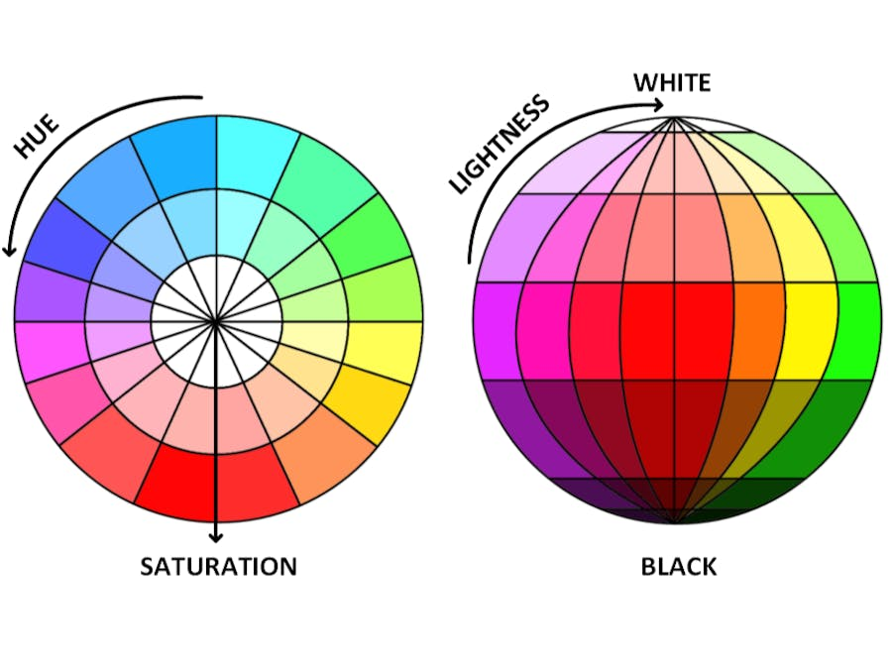
Specific hue values on the color wheel are detailed as follows:
- 0 degrees – Red
- 60 degrees – Yellow
- 120 degrees – Green
- 180 degrees – Cyan
- 240 degrees – Blue
- 300 degrees – Magenta
- 360 degrees – Red-Magenta

RGB Triplet Saturation Equation
The saturation in an RGB triplet is calculated by finding the maximum and minimum values among the Red, Green, and Blue channels. This process measures the strength of the color and the radius of the cone. When the maximum RGB component is subtracted by the minimum and divided by the maximum, white light is eliminated, resulting in a saturated color that corresponds to a single wavelength.
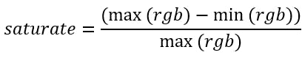
Enhancing saturation in the HSL color space during RGB to HSL and HSL to RGB conversion strengthens the RGB colors.

Image Enhancement Process: RGB to HSL and Back
The image enhancement pipeline starts with a video stream in the RGB color space. This stream is converted to HSL color space, where the values for Hue, Saturation, and Luminosity are updated linearly by multiplying each component with specific coefficients. This adjustment makes the image colors brighter and more vibrant. Following these enhancements, the HSL data is converted back to the RGB color space, resulting in natural and brighter image colors due to the applied gains.
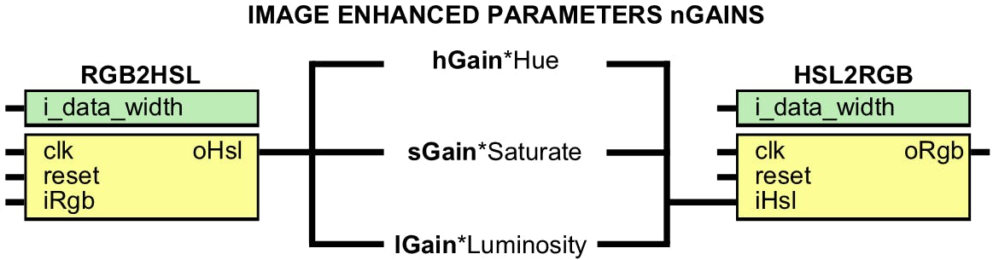
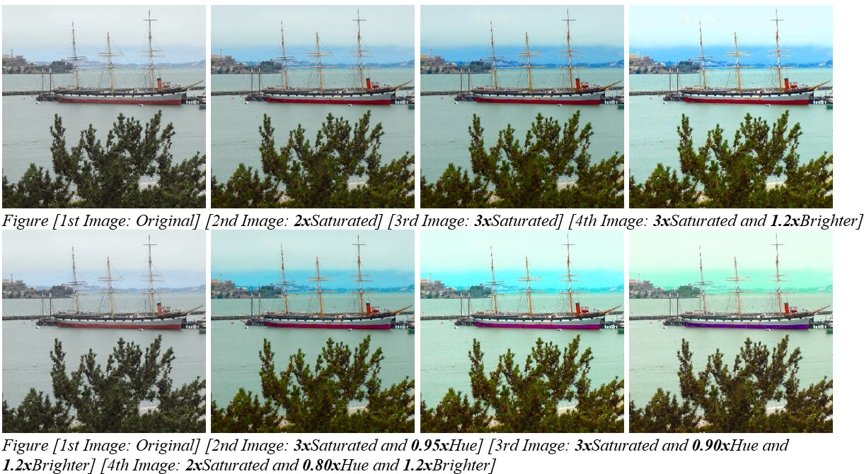

Implementation Details: RGB to HSL Conversion
The RGB to HSL conversion is implemented in a video color processing module using the HSL algorithm. This module features a standard Xilinx AXI4 streaming interface for seamless integration within image processing pipelines. The conversion logic begins by calculating the maximum and minimum RGB values. Depending on which RGB channel holds the maximum value, the hue fraction is determined:
- If Red is the maximum, the hue numerator is set to Green minus Blue (or vice versa), and the hue degree is set between 0 and 85.
- If Green is the maximum, the hue numerator is Blue minus Red (or vice versa), and the hue degree is between 86 and 171.
- If Blue is the maximum, the hue numerator is Red minus Green (or vice versa), and the hue degree is between 172 and 255.
The hue denominator is the RGB delta. After calculating the hue fraction, it is added to the corresponding hue degree to obtain the final hue value. Saturation is calculated as the difference between the RGB max and min, divided by the RGB max, while lightness is determined from the RGB max value. The module includes clock and reset ports, and the iRGB port contains the red, green, and blue components with a valid signal for converting incoming RGB pixels to HSL pixels. Simulation results for this conversion are presented in the wave diagram.

Implementation Details: HSL to RGB Conversion
The HSL to RGB conversion module also uses the HSL algorithm and is equipped with a standard Xilinx AXI4 streaming interface for integration into image processing pipelines. This module converts HSL input back to RGB color space. It features clock and reset ports, and the iRGB port carries the Red, Green, and Blue channels with a valid signal, facilitating the conversion from HSL pixels back to RGB pixels.

